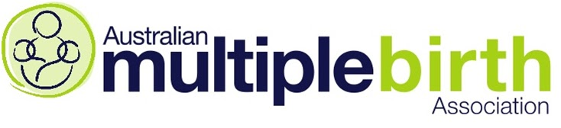
MEDIA RELEASE - for immediate release 5th February 2018

AMBA launches annual Multiple Birth Awareness Week to raise awareness about the wide range of resources and information it takes to support multiple birth families.

The Australian Multiple Birth Association (AMBA) today announced the theme for this year’s Multiple Birth Awareness Week (MBAW), running from 11th to 18th March 2018. The annual week-long event centres around running community events to raise awareness of the important work done by AMBA and local clubs around Australia in providing vital support to multiple birth families. In 2018, AMBA is focusing on raising awareness around the strength that comes from being supported by an effective network.

The theme for Multiple Birth Awareness Week (MBAW) 2018 is ‘Strength in Numbers’.

Strength comes from being supported by an effective network. Numbers mean many things in various contexts: number of club members; number of AMBA volunteers; financial support of our charity; number of supporting organisations; maintaining membership growth; research data that enables us to advocate for our members' needs.

AMBA Chairperson, Ashlee Tenberge said: "For AMBA in 2018, strength in numbers represents significant milestones in our charity's journey. We have been working for 44 years to offer guidance and support to a community group with unique needs. Our strength now more than ever is that AMBA offers a peer support network for member families. To offer a rounded experience for multiple birth families, we depend on the expertise of other like-minded organisations like PANDA, ABA, Miracle Babies and more."

"Multiple birth families are vulnerable. Offering emotional and social support is what our organisation is all about. Every day, our volunteers enable families with twins, triplets or more to find their strength by providing information and support. It's about connecting these families with a wide community so that they know they are not alone.”

Many families with multiples have travelled, or still are travelling, a long and difficult road. The task of carrying, delivering and raising two or more children at once is extremely demanding with many associated risks and challenges.
- 4,375 total multiple births in 2015
- Up to 65% of all multiples are born preterm (80% if triplets or more)
- Low birth weight occurs in 50% of all twin births, and 95% of triplet and higher order multiple births
- 15% of identical twins are affected by Twin to Twin Transfusion Syndrome
These are the numbers that unite multiple birth families. These are the numbers that give strength to AMBA’s cause. A cause about providing more support to families with multiples across Australia. ‘Support from those who know’.

We encourage families, schools and support organisations to discover more by visiting www.amba.org.au and www.facebook.com/AustralianMultipleBirthAssociation.
AMBA has a growing list of events for MBAW around Australia; we invite you to contact us or go to www.amba.org.au/clubfinder to find a contact for your local AMBA club or to organise a photo of a local family with twins, triplets or more.

< ENDS >

For more information, contact:
Ashlee Tenberge, Chairperson
chairperson@amba.org.au
Mobile: 0438 679 773
www.amba.org.au

ABOUT OUR ORGANISATION
The Australian Multiple Birth Association (AMBA) is a not-for-profit organisation comprising of multiple birth families. The organisation provides support, resources and education to multiple birth families from “those who know”.

